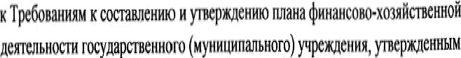

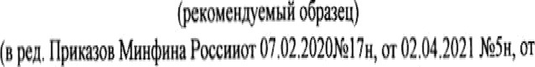

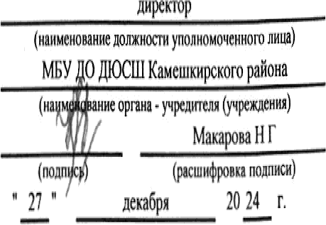

Ił/l1H țHH8HC0B0”I0›gğ¢ ştHH0ł zțeTMbH0(TH IU łł r.

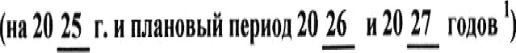



} ÿ( (ø(Ç j #Ł(N Ó0 Œm(X)M CŁØCAOØOIØÆRâ#ŁOQOÓ[[|OØŒŁØÆ"jlÛÛ Ä8MOWŁ#ÿOÆOf0ÿ ###'





Fe M I. ÏIOtTyI/ItHHs H B6IMtTsI

##### D0ÛB0A#0/|Kt }

fØAAŒM0ÔK



%!!

fi0(B0A#0/ DȚ}

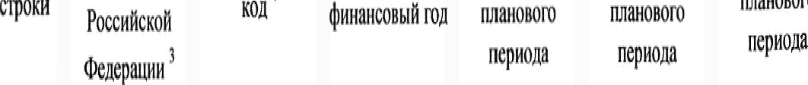

AOOØIOTOOÓDBÜOGØBOBO

IIU

llOO

ÄOAMO

##### ÄOÂ

OM

ŽOOÛŽOEOŽ

##### j atOBaÅpg

##### W|M0#0U

##### 0ł0O

##### f|]N0B0M

7 D

##### Ø # Ø£AMOOØ0C0ÓOOMO8OØZ0ł@M0ÆØOØ|] OBO££O0(/mZ x|MfØ0|D)

0 0a 0ł øIțt‹|›o,›I¢lt¢ł, h›uIz ¢ł M il Mlłïz› IUI›IIOD i ru, ROI 0

z|#œp‹M <;‹mm +;MilOWCxf jOÆOA@(ŒOCÿNWŽO8K|T#ØMØØXR)

y TOM1MMt.

### llltî lllt

Ill IU

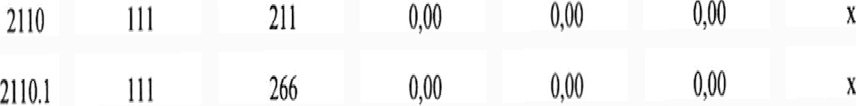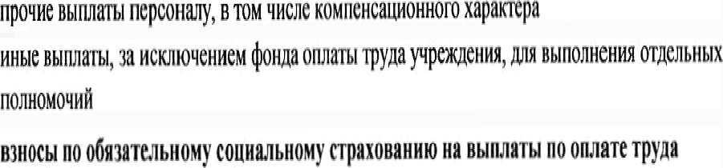

łl4 IU



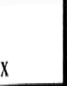

ÑNl¥¢Ø0#WØtO0 | UN

'

N|[I0NN

pØ0A#

|  |  |  |
| --- | --- | --- |
| ltÇCZÓ | ØOÿB@Åf0A | 8Dÿ! Æ |
| ğØMŒ#RÅ|W | WW0#0N | 4MW0#0M |
|  | M@N0/ | ØØM0A# |
|  | A | 7 |



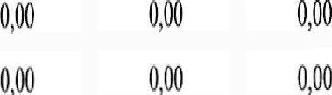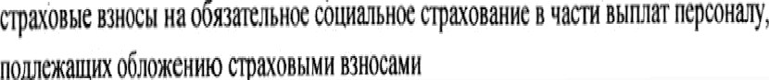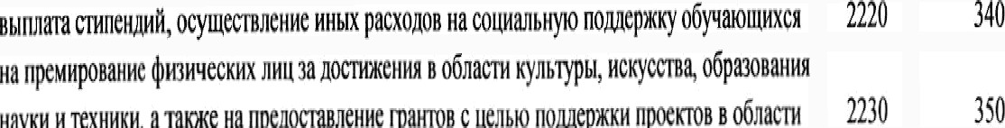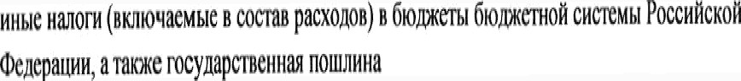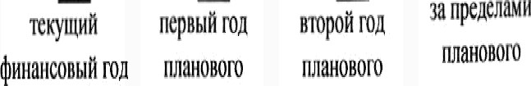

Mt MQ»

:t ,0

flOÿ OJŒ

§0 ¿0T0p¡( 0cØcf01;1)DÆŁOÑCØCTtNÑ ËOlĘJDtØHT ###

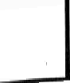

)DŁMõ0BAH#t10KŒòt2#

fUll8080f0

’*’*’

4

סװסוװוסזםזםסח cMCHOIImBaHMCMcucremw‏!}שהמשתמש

Kenna

Cymma

Haumeuomuenoxazmm

1

#### npouym ם‎מחמ Tonapma. ן‎םנ00ז *u* ycnyr, scorn

**H3 HHX:**

***ycnym*00m**

**0000340000000** ycnym

**p060m, *ycnym* no**conepmaumo **umymema**

טװּויסםװpaﬁom. **vcnym‏**

**0100000000**

**WCJ'IMHCHHG CTOMMOCTH 11110me 111113111111**

**(!000010000000000001140000010000)cpencm**

**yBCﬂM‘ICNKC CTOHMOCTM CTPOWNJIBHMX M010p11111100**

**ynenmeuue 0000000104 npoqnx 0601300000 3000000 KC040201000000002**

**(1000000000 CTOl/IMOC'I‘H 11110111111 MaTepl/IﬂﬂbelX 3111111000 OAHOKpﬂTHOFO HpVIMCHCHHﬂ**

**KC040201000000002**

#### 0800000000 101000000 006103010] mayﬂﬂpmcunon }00000008000001006000000010 seem

**1110M 01101102**

**0000000000 06000100 0000000000 0000180100 rocynapcraeuubmu )000000000000001**

**0000010000100** (pemHmpyKum) **06000100!0000000000 0001000100 0000000000000000**

**)000000000000001000600000000**

Bunnam, ymmmawmue 00x00, mm 0

Ken

crpoxu

**2**

**2640**

**2640.1**

**26402**

**2640.3**

**26404**

**26405**

**26406**

**2640.7**

**2640.8**

**26409**

**264010**

**2650**

**2651**

**2652**

**3000**

6mmuemon

װװװםאװשװסספת‎א

Poccnﬂcxoﬁ

tIxnepatumנ‎

**3**

**244**

**244**

**244**

**244**

**244**

**244**

**244**

**244**

**244**

**244**

**244**

**400**

**406**

**407**

**100**

Annnumqecm

**4**

“011

**4**

**221**

**223**

**225**

**226**

**227**

**342**

**310**

**344**

**346**

**349**

##### Ha2025 r.

־‎

הממושך

**¢Huauconb|ﬁmﬂ**

**5**

**3000000**

# 0,00

**0,00**

**0,00**

# 0,00

**0,00**

## 0,00

**0,00**

## 0,00

**20000,00**

**1000000**

##### Ha2026 r.

־י־

**nepnbm** ₪1

**mauosoro**

**ncpuona**

### 6

**30000,00**

# 0,00

**0,00**

**0,00**

# 0,00

**0,00**

## 0,00

**0,00**

## 000

**2000000**

**10 00000**

##### Ha2027 r.

־ **mpon** ₪1

**סזסםסּושת‎װ**

**nepuona**

### 7

**30000,00**

# 0,00

**0,00**

**0,00**

# 0,00

**0,00**

## 0,00

**0,00**

## 0,00

**2000000**

**10000,00**

**3anpeneuaw**

**11113110110“)**

**ncpuona**

***8***

**1**

**X**

**01100 111101182**

**000000000060001**

**00000000060000000 0100006001**

**11**

**1111011110 ,1101101171 YMCHBIIJBJOIHMC11011011**

**1100000 ,001000701 000m9**

**03 110113**

**3010**

**3020**

**3030**

**4000**

**4010**

**X X X**

**x X**

**610 X**

' Bummympmem 380000(pemmmoﬁlouxm 0000001011 0000000000 ₪10!0000000 !1000010

#### 2 Vmunams um0000000000 ,110000a*0*0000000000000000 1100080000000000000 00000 ("10000190-00 08130100000000 110000

**1** Brpa¢e**1:003300000100**

1101101100;6101000000 1000000000000 uoxonon6101100000 שפנת‎ה rpyrmu װסאססףװחתהװם עגנו!‎» -190*-*0 I100 משק‎טno

no0113010001980 י‎ 1990 -עונשו ֹווסאססףוװװושװטrpynnu 000130010400000 chumcupoaauus ת‎משומש 6ו₪110ז₪0 000000010wa0 0000400000 chummponam neclmumos;6102000100 nomom 2000 *-*265*-*2 !‎»אגנס ססגװװוpnoxonos!‎”ומשוב 0110000011an pacxonon 600mm;

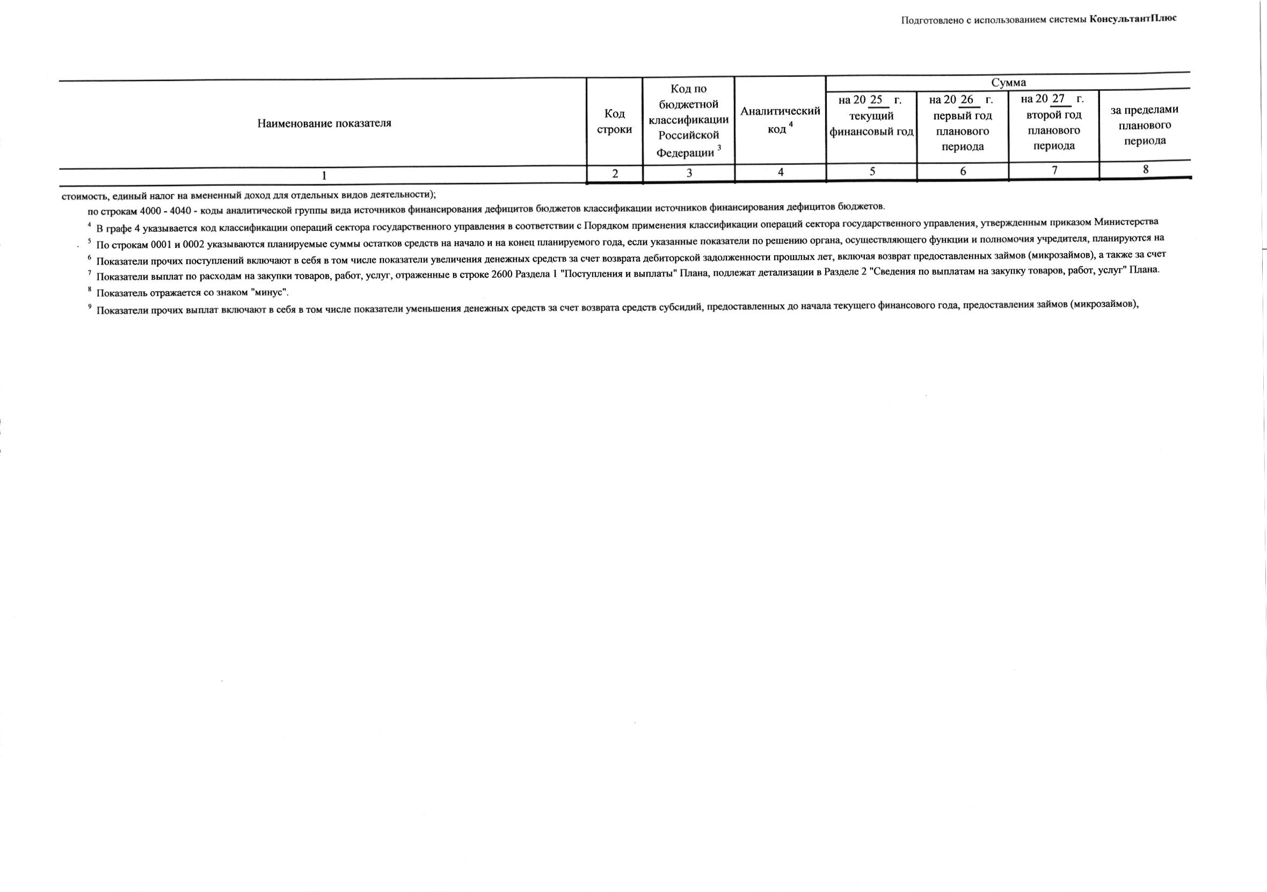



|  |  |  |  |  |  |  |  |  |  |  |
| --- | --- | --- | --- | --- | --- | --- | --- | --- | --- | --- |
|  | | |  |  | ÓDŒCWOz  I¢ I |  |  | | | |
|  |  |  |  |
|  | |  |  |  |  |  |  |  |  |  |
|  |  | |  |  |  |  |  |  |  |  |
|  |  | |  |  |  |  |  |  |  |  |
|  |  | |  |  |  |  |  |  |  |  |
|  |  | |  |  |  |  |  |  |  |  |
|  | ş(, /,(p#({›œ)lzax łxwxDmium,(xŁn#‹œomuyuc¥¢xllÆlçoæ¥|og/nW  ,0œgi0mì Æ.Øl & 0 #OHg'0NÑiž83" | |  |  |  |  |  |  |  |  |
|  |  | |  |  |  |  |  |  |  |  |
| I.4.I. |  | |  |  |  |  |  |  |  |  |
| },4 |, |  | |  |  |  |  | *0,t0* | 0,00 |  |  |
|  |  | |  |  |  |  |  |  |  |  |
|  |  | |  |  |  |  |  |  |  |  |
|  |  | |  |  |  |  |  |  |  |  |
|  |  | |  |  |  |  |  |  |  |  |
|  |  | |  |  |  |  |  |  |  |  |
|  |  | |  |  |  |  |  |  |  |  |
|  |  | |  |  |  |  |  |  |  |  |
|  |  | |  |  |  |  |  |  |  |  |

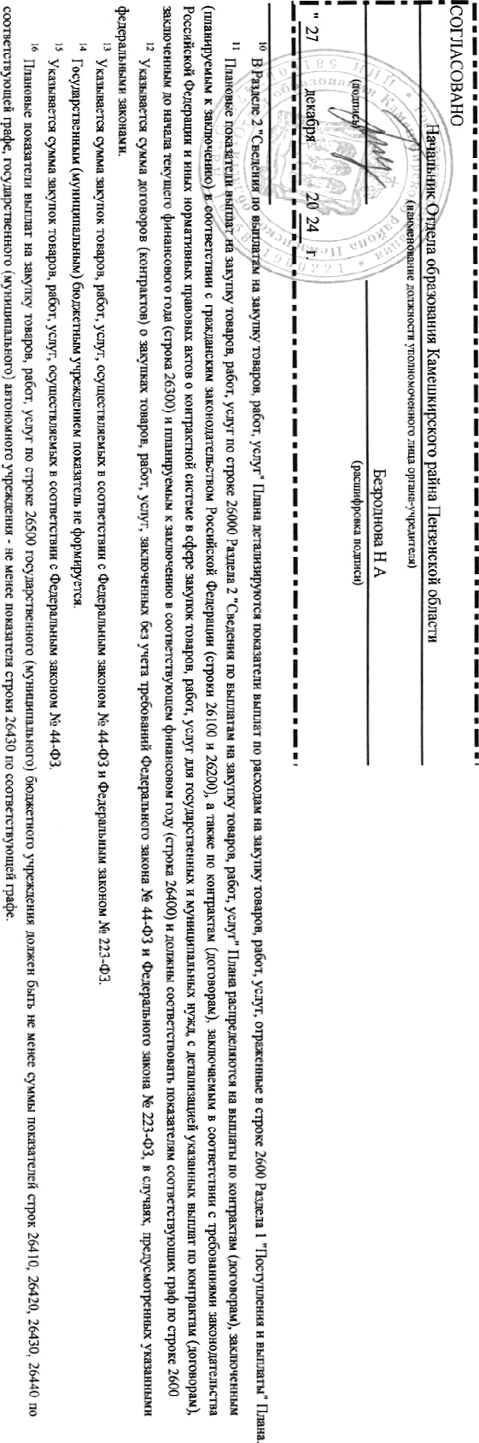 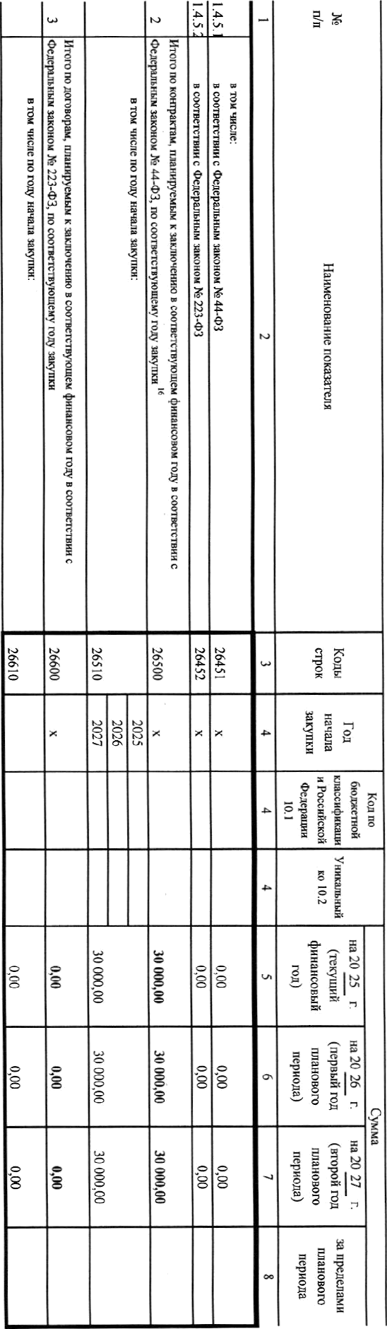

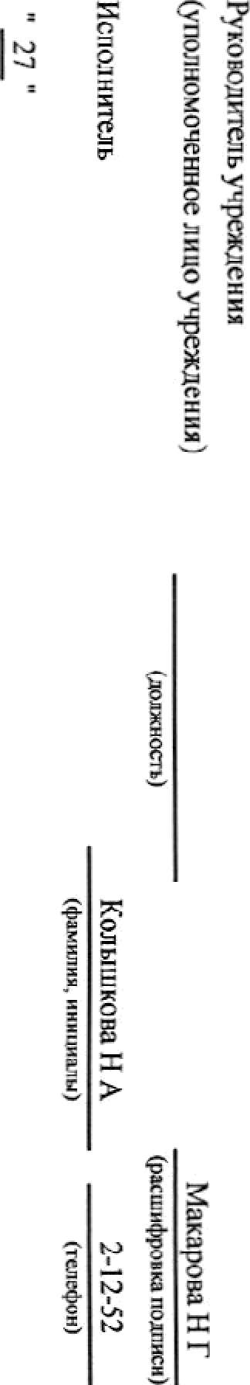

0

s

o

I

n

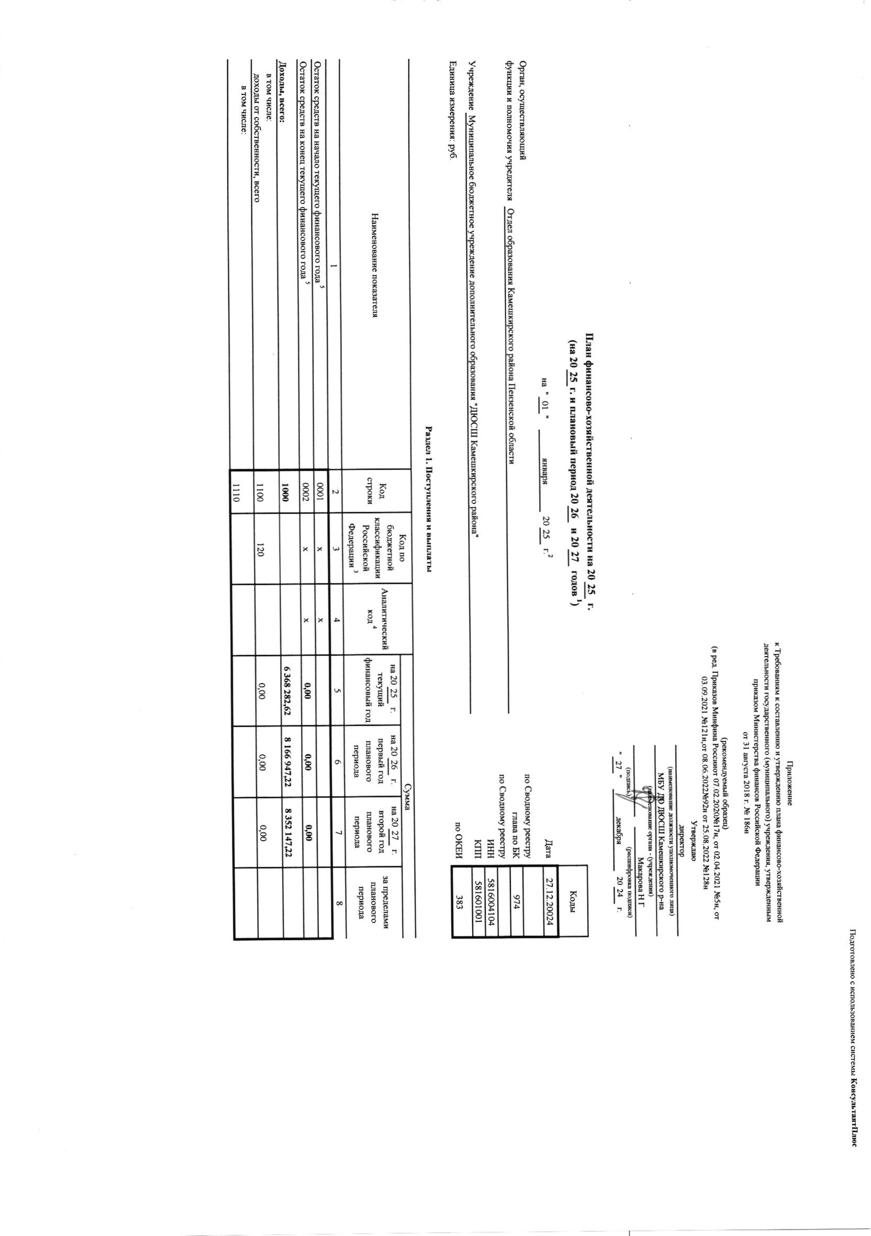



l)l

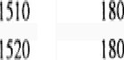

IłN

ISO

HO

llłfl III



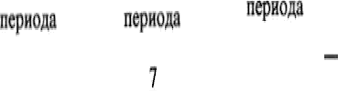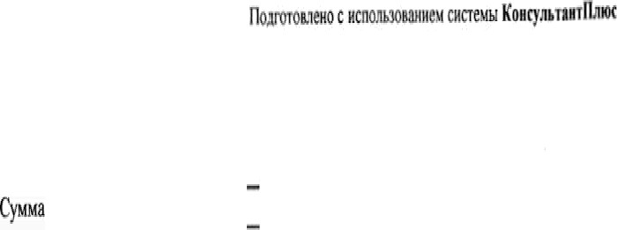

;ims*œ oO uKCîüYBT0ü

I

O,(0

iŒ w0mØ+sexæimmN œg*ğ8umn4fommoÆœn'xsåm'dDÆ



O,OO

0,00

0,ß

DOO A COM.¥M: NW0iiw(ÆOXOA'

